Colleague Recommending a New Client
- Recommend a new Client for Simpson Millar services and receive payment as below:
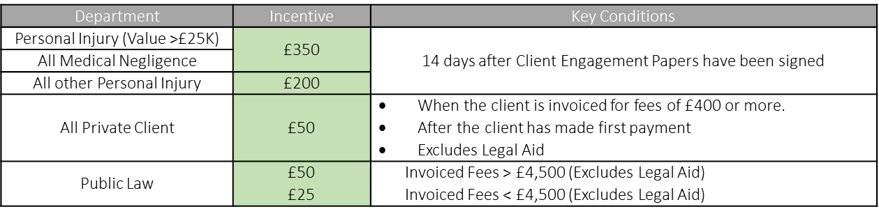
- All incentives are payable in your monthly pay in the month after you become eligible for payment.
- All incentives are subject to Tax & NI at your usual rate.
- A New Client is defined as one who has not already instructed Simpson Millar.
- You must complete the online form providing the new clients information to be eligible for the incentive.
- The information you provide about the New Client must have been given to you directly. By submitting the online form you confirm that you have not received the details from any other person or intermediary other than the New Client.
- Payment will only be issued if the New Client meets the key conditions outlined in the table above.
- To be eligible for the Client Recommendation Incentive, the client you recommend must instruct us for a service provided by a department that you do not work in. For example: An RTA Fee earner will not receive an incentive for recommending a client to RTA, but they would receive an incentive if they recommended a client to ELPL.
- This incentive cannot be claimed where the client claims a discount on the service they are recommended for in conjunction with another offer or promotion
- The value of the incentive will be determined at the time the case is opened.
- We are authorised & regulated by the Solicitors Regulation Authority (SRA) and by participating in the recommend a new client scheme you agree that you are doing so in the course of your employment with Simpson Millar and that you will not make any unsolicited approaches to prospective clients.
- If a breach is suspected, no payment will be made whilst an investigation is carried out. If a breach has occurred no payment will be made and you may face disciplinary action.
- You can only recommend our services to clients who are 18 years of age or older, or where the prospective client is under 18 years of age, to the person who is legally responsible for them.
- This promotion is open to all employees of Simpson Millar except members of Simpson Millar Leadership Team (SMLT) and/or where the main purpose of their role is to introduce new clients to Simpson Millar.
- By participating in this scheme, you agree to be bound by these terms and conditions, and that the decision of Simpson Millar is final and binding in all matters relating to this Promotion.
- The colleague who makes the recommendation must be employed by Simpson Millar when the recommendation is made and when the incentive is due for payment. Where the colleagues’ contract of employment is under notice of termination (whether given by the employer or the employee) at the time of recommendation any incentives you may have been eligible for will not be paid and no payments will be made after employment has ceased.
- Simpson Millar reserves the right to cancel or amend the terms of this promotion without notice.
- The closing date of this promotion is 31/12/2022.
- Any personal data collected for the purposes of the Promotion will be processed in accordance with the provisions of Simpson Millar's Privacy Policy.
- This Promotion is governed by the laws of England and Wales.

